WEB TECHNOLOGY LAB
EXP.NO: 8
DATE: 23/03/2026

AIM:
To develop an Android application to change the font and color of text and display a toast message on button click.

ALGORITHM:
1. Create Android project.
2. Design UI with TextView and Button.
3. Declare variables.
4. Set OnClickListener.
5. Change font using setTypeface().
6. Change color using setTextColor().
7. Show Toast message.
8. Handle toggle logic.

PROGRAM:

activity_main.xml
<?xml version="1.0" encoding="utf-8"?>
<androidx.constraintlayout.widget.ConstraintLayout
xmlns:android="http://schemas.android.com/apk/res/android"
android:layout_width="match_parent"
android:layout_height="match_parent">
<TextView
android:id="@+id/sampleText"
android:layout_width="wrap_content"
android:layout_height="wrap_content"
android:text="Hello World"
android:textSize="24sp"/>
<Button
android:id="@+id/changeStyleButton"
android:layout_width="wrap_content"
android:layout_height="wrap_content"
android:text="Change Style"/>
</androidx.constraintlayout.widget.ConstraintLayout>

MainActivity.java
package com.example.font_change;
import android.graphics.*;
import android.os.Bundle;
import android.widget.*;
import androidx.appcompat.app.AppCompatActivity;
public class MainActivity extends AppCompatActivity {
TextView text;
Button btn;
boolean changed=false;
protected void onCreate(Bundle b){
super.onCreate(b);
setContentView(R.layout.activity_main);
text=findViewById(R.id.sampleText);
btn=findViewById(R.id.changeStyleButton);
btn.setOnClickListener(v->{
if(!changed){
text.setTextColor(Color.RED);
text.setTypeface(Typeface.DEFAULT_BOLD);
Toast.makeText(this,"Changed!",Toast.LENGTH_SHORT).show();
}else{
text.setTextColor(Color.BLACK);
text.setTypeface(Typeface.DEFAULT);
Toast.makeText(this,"Reset!",Toast.LENGTH_SHORT).show();
}
changed=!changed;
});
}
}

OUTPUT:

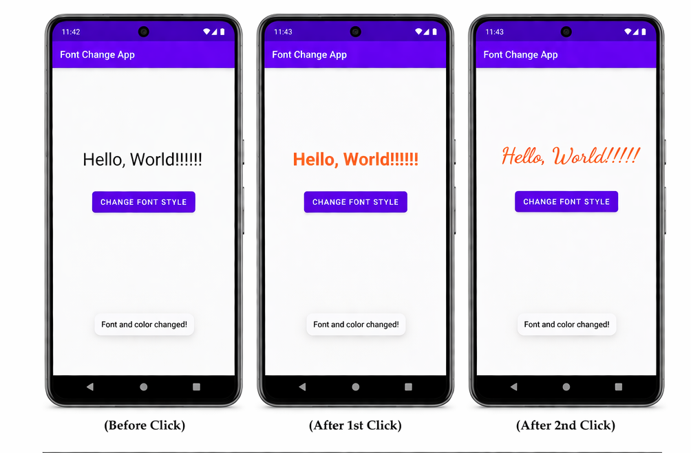

RESULT:
Android app executed successfully.

